**DIGITAL MARKETING**

ASSIGNMENT – 1

|  |  |
| --- | --- |
| Name | Aswini Muratha. E |
| Reg no | 960220106036 |
| NM id | 0426A443B64EDDDAF7C4EE4FD1CD4D34 |
| Team id | NM2023TMIDO2667 |

**Create a blog or website using blogspot and wordpress.Customized the theme design and post new article with 500 words.**

**BLOGGER:**

[**https://healthpulsehubhealthy.blogspot.com/2023/08/health-pulse-hub_25.html**](https://healthpulsehubhealthy.blogspot.com/2023/08/health-pulse-hub_25.html)

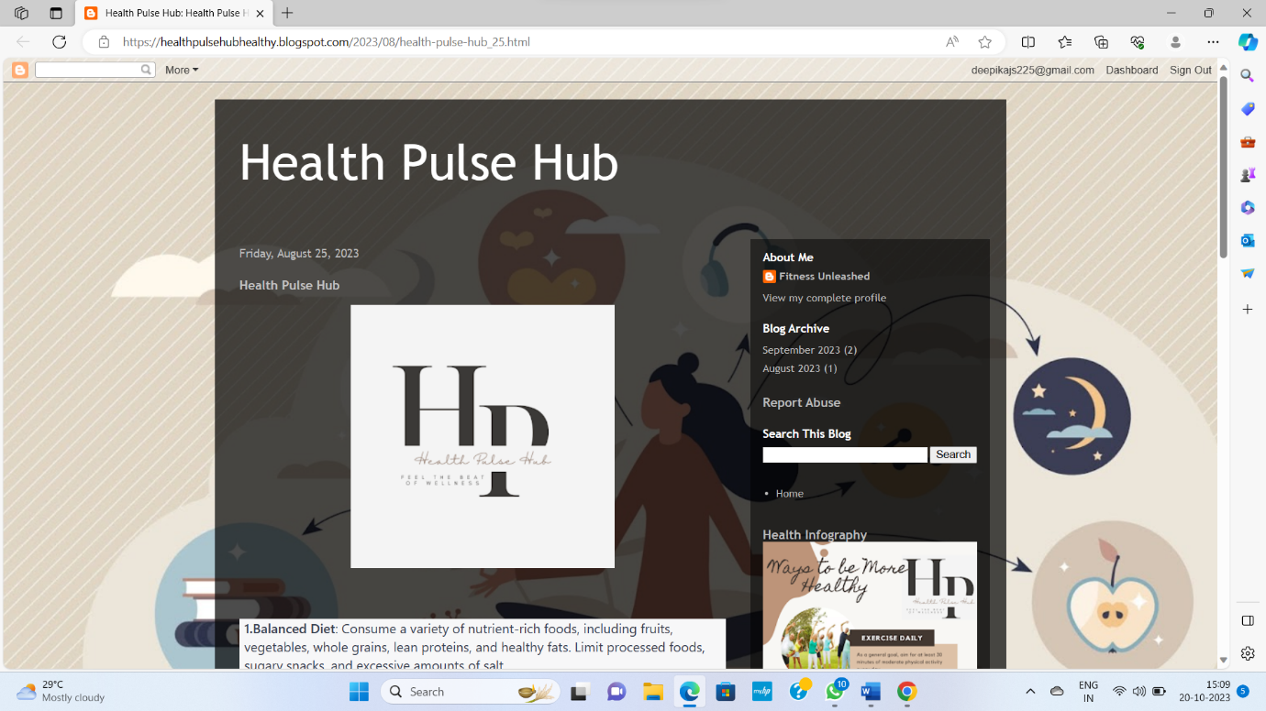

**WORDPRESS:**

[**https://healthpulsehub.wordpress.com/2023/10/13/fitness-unleashed/**](https://healthpulsehub.wordpress.com/2023/10/13/fitness-unleashed/)

